LINUX INTERNALS MULTITHREADING ASSIGNMENT
Vandit Prajapati (150187)

Q-1)

#include<stdio.h>
#include<pthread.h>
#include<stdlib.h>

void *fun()
{
printf("Executing thread after main function termination\n");
sleep(2);
return 0;
}

int main()
{
//Creating a thread object
pthread_t tid;

//Creating thread
pthread_create(&tid,0,fun,0);

printf("Main process executing\n");

printf("Main function terminated\n");

//Pending thread executing
pthread_exit(NULL);
return 0;
}

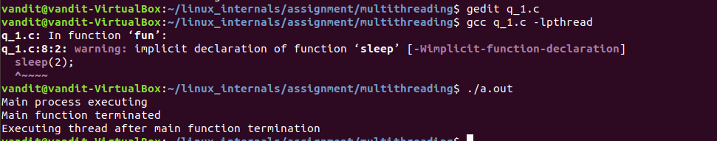

Q-2)

#include<string.h>
#include<stdio.h>
#include<pthread.h>

struct information
{
int tid;
char a[100];
};

void *fun(void *inf)
{
struct information *i;
i=(struct information *)inf;
printf("Thread Message :\ntid: %d\nMSG: %s\n",i->tid,i->a);
}

int main()
{
pthread_t t1,tid;
int rc;
struct information inf;

inf.tid=4;
strcpy(inf.a,"My name is Vandit\n");

//Passing structure object as argument
pthread_create(&t1,NULL,fun,(void *)&inf);

pthread_exit(NULL);
printf("Exit Main Thread \n");
}

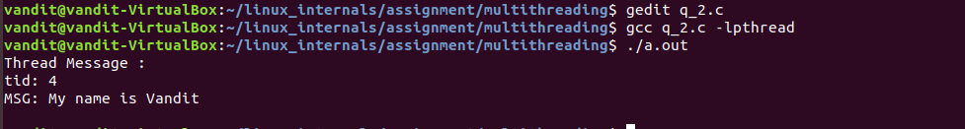

Q-3) Write a pthread program that implements simple initialization code.

#include<stdio.h>
#include<pthread.h>

//For running initialization code
pthread_once_t once=PTHREAD_ONCE_INIT;

//Initialization code
void *intialization_code()
{
printf("Initialization code running\n");
sleep(2);
}

//Thread Function
void *fun()
{
pthread_once(&once,(void *)intialization_code);
printf("Executing Thread\n");
sleep(2);
printf("Exiting from thread\n");
}

int main()
{
pthread_t t;

t=pthread_create(&t,NULL,fun,NULL);
pthread_exit(NULL);
printf("Exiting from main program\n");
}

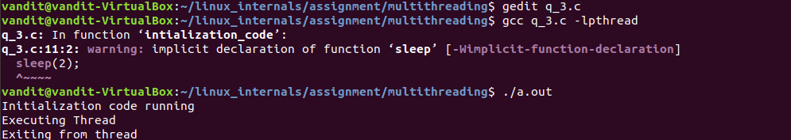

Q-4) Write a program, which get and set pthread scheduling policy and priority.

#include<stdio.h>
#include<pthread.h>
#include<sys/types.h>
#include<unistd.h>

void *fun()
{
printf("Thread executing\n");
}

int main()
{
pthread_t tid;
struct sched_param param;
int priority,policy,ret;

//getting the scheduling policy and parameter
ret=pthread_getschedparam(pthread_self(),&policy,&param);

printf("Policy : %d\t Priority : %d\n",policy,param.sched_priority);

//setting the Round Robin policy
policy=SCHED_RR;
//setting the priority as 3
param.sched_priority=3;s
//Setting the priority and policy
ret=pthread_setschedparam(pthread_self(),policy,&param);

//Getting the new values of priority and policy
ret=pthread_getschedparam(pthread_self(),&policy,&param);
printf("New Policy : %d\t New Priority : %d\n",policy,param.sched_priority);

return 0;
}
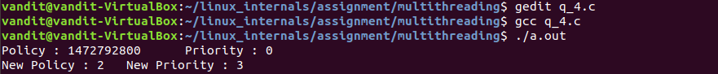

Q-5) Write a program that implements threads synchronization using pthread spinlock techniques.

#include<stdio.h>
#include<pthread.h>
#include<stdlib.h>
#include<unistd.h>
#include<errno.h>
#include<bits/types.h>
#include<sys/types.h>

static pthread_spinlock_t spinlock;
volatile int slock;

void *spinlockthread(void *i)
{
int rc;
int count=0;
printf("Thread aquiring spinlock\n");
rc=pthread_spin_lock(&slock);
printf("Thread executing\n");
printf("Unlocking spin lock\n");
rc=pthread_spin_unlock(&slock);
return NULL;
}

int main()
{
int rc=0;
pthread_t thread;

if(pthread_spin_init(&slock,PTHREAD_PROCESS_PRIVATE)!=0)
perror("init");

printf("Main function aquiring spin lock\n");
rc=pthread_spin_lock(&slock);

rc=pthread_create(&thread,NULL,spinlockthread,(int *)1);

printf("Executing main function\n");
sleep(5);

printf("Main unlocking spin lock\n");
rc=pthread_spin_unlock(&slock);

if(rc==0)
printf("\nMain Thread Successfully unlocked \n");
else
printf("\nMain Thread Successdully unlocked \n");

printf("Main function waiting for thread to complete execution\n");
rc= pthread_join(thread,NULL);
printf("Main completed \n");
return 0;
}

